English 3201 Name: ________________________

Wasps’ Nest (Quest text page 299)
A classic mystery story written by Agatha Christie, AKA the Queen of Crime.

Mystery stories:
- Build suspense
- Engage readers with a mystery, crime or puzzle that needs to be solved
- Leave gaps in the story that the reader has to fill in
- Use foreshadowing - hints the author gives readers about what it going to happen
- Give clues about the mystery, sometimes obvious, sometimes subtle
- Have red herrings, that is, false suspect(s) meant to lead readers to the wrong conclusion
- Have a reveal or twist in which the mystery, crime, or puzzle is solved.

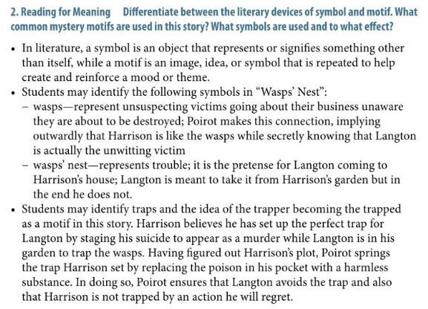

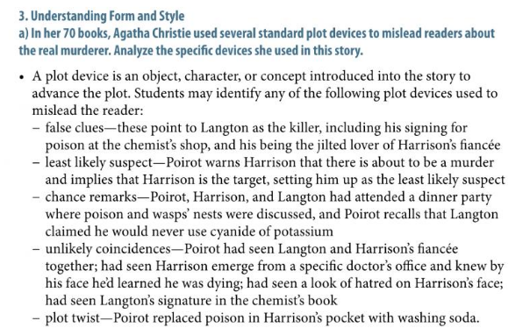

Complete the following questions after reading the story.

- Which point of view is used to tell the story?
  - First person
  - Second person
  - Third person limited
  - Third person omniscient

- What do we learn about John Harrison’s current situation from his description in the first paragraph?
  - He’s an avid gardener
  - He’s extremely wealthy
  - He’s led a hard life
  - He’s unusually happy

- What mood is developed in the second paragraph?
  - Calm
  - Expectant
  - Lonely
  - Suspenseful

- In the second paragraph, the line, “The rambler roses were still beautiful; sweet peas scented the air” is an example of this literary device.
  - Foreshadowing
  - Imagery
  - Metaphor
  - Simile

- What is Harrison’s initial reaction to discovering his unexpected visitor is Monsieur Poirot?
  - Fake happiness
  - Genuine happiness
  - Hidden fear
  - Sudden doubt

- Who was Miss Molly Deane engaged to first?
  - Claude Langdon
  - John Harrison
  - Monsieur Poirot
  - The chemist in Barchester

- The story Poirot shares about once knowing a pickpocket is an example of this.
  - Allegory
  - Allusion
  - Anecdote
  - Flashback

- Identify two motives behind Hercule Poirot’s visit to John Harrison. How do these motives help develop/reveal the detective’s character? (6 marks)

In the short story “Wasps’ Nest”, there are two motives behind Hercule Poirot’s visit to John Harrison. The first motive is that he wanted to prevent Claude Langton from succumbing to “the worst death any man can die” that being a hanging punishment for a crime he didn’t commit. Harrison planned to frame Claude for his death, even though he was already dying from an incurable disease, to punish him for stealing his fiancé. This reveals that the detective is a protector of the innocent, and is very noble in his effort to uphold justice and honor. The second motive stems from the fact that he genuinely liked Harrison. He pities Harrison and this is revealed when he says “you are a dying man; you have lost the girl you loved, but there is one thing that you are not: you are not a murderer.” By interfering with Harrison’s plans Poirot nobly preserves Harrison’s honor and dignity by preventing him from becoming a murderer out of spite and anger. Poirot is concerned with preserving Harrison’s humanity and this speaks to his compassion as an individual.

- Explain the significance of the title, making reference to both its literal and symbolic meaning. (6 marks)

The title “Wasp’s Nest” functions on two different levels. On the one hand it literally refers to the set up that Harrison was planning to frame Langton for stealing his fiancé. He had tricked Langton into purchasing the “cyanide of potassium – at your [Harrison’s] request” - poison with which Harrison was going to use against his ‘enemy’. His plan was foiled when Poirot “uncorked the bottle…poured the solution into the wasps’ nest…and then [they] lay still”. This being said, on a more symbolic level, a wasps’ nest is a dangerously deceptive creation. While it seems papery and delicate in its construction, inside there lurks great pain and danger that can befall the unlucky individual who has disturbed it. Just as Claude disturbed Harrison’s life by rekindling his relationship with Molly Deane as is evidenced in the quote, “I do not know what lovers' quarrel it was that originally parted them and drove her into your arms, but I realized that misunderstandings were over and that Miss Deane was drifting back to her love”, so too did Harrison’s sickness disturb the pain and suffering within himself. As he lashed out again Langton for his actions, Harrison became the wasp dangerous and deceptive as he lay in wait for his chance to strike. In these ways, it is evident that the title is appropriate for the story on a variety of levels.

- What moral lessons does the author deliver in this story? Through which character does she deliver these messages? (6 marks)

The moral lessons that the author intends on delivering to the audience includes the idea that we all have difficult choices to make when dealing with the obstacles set before us in life, as well as the idea that we are able to ensure that justice can be served when people make the choice to act. The first moral is shown through the character of Harrison as he does not deal with the obstacles of his fiancé potentially leaving him and his impending death from his illness in the most mature of ways. He plots to punish Claude Langton for taking away his fiancé by framing him for his own impending death. This is shown when it states, “________________________________________
__________________________________________________________________________________________”. Meanwhile, the second moral lesson is delivered through the character of Poirot as he cleverly puts together his observations regarding Harrison’s and Langton’s actions/behaviors. This is shown when he says “_____________
_______________________________________________”. When questioned by Harrison as to “why [did] he come?”, Langston reveals that he was motivated by a choice to fulfill justice and to additionally protect his friend’s honor. This is revealed in the quotes which state “_____________________________________________
__________________________________________________________________________________________”. It is therefore evident that there are multiple moral lessons being taught throughout this short story.

